Paper’s title should be the fewest possible words that accurately describe the content of the paper (Center, Bold, 16pt)

Masitah Shahrill¹, Hanif Cahyo Adi Kistoro^{2,3}, Azlina Mohd Kosnin⁴ (10 pt)
¹Sultan Hassanal Bolkiah Institute of Education, Universiti Brunei Darussalam, Bandar Seri Begawan, Brunei Darussalam (8 pt)
²Department of Educational Research and Evaluation, Graduate School, Universitas Negeri Yogyakarta, Yogyakarta, Indonesia
³Department of Islamic Education, Faculty of Islam Religion, Universitas Ahmad Dahlan, Yogyakarta, Indonesia
⁴Faculty of Social Sciences and Humanities, School of Education, Universiti Teknologi Malaysia, Skudai, Malaysia

Article Info |  | ABSTRACT (10 PT)
Article history:  Received mm dd, yyyy  Revised mm dd, yyyy  Accepted mm dd, yyyy |  | An abstract is often presented separate from the article, so it must be able to stand alone. A well-prepared abstract enables the reader to identify the basic content of a document quickly and accurately, to determine its relevance to their interests, and thus to decide whether to read the document in its entirety. The abstract should be informative and completely self-explanatory, provide a clear statement of the problem, the proposed approach or solution, and point out major findings and conclusions. The Abstract should be 100 to 200 words in length. References should be avoided, but if essential, then cite the author(s) and year(s). Standard nomenclature should be used, and non-standard or uncommon abbreviations should be avoided, but if essential they must be defined at their first mention in the abstract itself. No literature should be cited. The keyword list provides the opportunity to add 5 to 7 keywords, used by the indexing and abstracting services, in addition to those already present in the title (9 pt).
Keywords:
First keyword
Second keyword
Third keyword
Fourth keyword
Fifth keyword
This is an open access article under the CC BY-SA license.

Corresponding Author:
Azlina Mohd Kosnin
Faculty of Social Sciences and Humanities, School of Education, Universiti Teknologi Malaysia
Sultan Ibrahim Chancellery Building, Jalan Iman, 81310 Skudai, Johor, Malaysia
Email: p-azlina@utm.my

- INTRODUCTION (10 PT)
The main text format consists of a flat left-right columns on A4 paper (quarto). The margin text from the left and top are 2.5 cm, right and bottom are 2 cm. The manuscript is written in Microsoft Word, single space, Time New Roman 10 pt, and maximum 12 pages for original research article, or maximum 16 pages for review/survey paper, which can be downloaded at the website: http://ijere.iaescore.com.
A title of article should be the fewest possible words that accurately describe the content of the paper. The title should be succinct and informative and no more than about 12 words in length. Do not use acronyms or abbreviations in your title and do not mention the method you used, unless your paper reports on the development of a new method. Titles are often used in information-retrieval systems. Avoid writing long formulas with subscripts in the title. Omit all waste words such as "A study of ...", "Investigations of ...", "Implementation of ...”, "Observations on ...", "Effect of.....", “Analysis of …”, “Design of…”, etc.
A concise and factual abstract is required. The abstract should state briefly the purpose of the research, the principal results and major conclusions. An abstract is often presented separately from the article, so it must be able to stand alone. For this reason, References should be avoided, but if essential, then cite the author(s) and year(s). Also, non-standard or uncommon abbreviations should be avoided, but if essential they must be defined at their first mention in the abstract itself. Immediately after the abstract, provide a maximum of 7 keywords, using American spelling and avoiding general and plural terms and multiple concepts (avoid, for example, 'and', 'of'). Be sparing with abbreviations: only abbreviations firmly established in the field may be eligible. These keywords will be used for indexing purposes.
Indexing and abstracting services depend on the accuracy of the title, extracting from it keywords useful in cross-referencing and computer searching. An improperly titled paper may never reach the audience for which it was intended, so be specific.
The Introduction section should provide: i) a clear background, ii) a clear statement of the problem, iii) the relevant literature on the subject, iv) the proposed approach or solution, and v) the new value of research which it is innovation (within 3-6 paragraphs). It should be understandable to colleagues from a broad range of scientific disciplines. Organization and citation of the bibliography are made in Institute of Electrical and Electronics Engineers (IEEE) style in sign [1], [2] and so on. The terms in foreign languages are written italic (italic). The text should be divided into sections, each with a separate heading and numbered consecutively [3]. The section or subsection headings should be typed on a separate line, e.g., 1. INTRODUCTION. A full article usually follows a standard structure: 1. Introduction, 2. The Comprehensive Theoretical Basis and/or the Proposed Method/Algorithm (optional), 3. Method,
4. Results and Discussion, and 5. Conclusion. The structure is well-known as IMRaD style.
Literature review that has been done author used in the section "INTRODUCTION" to explain
the difference of the manuscript with other papers, that it is innovative, it are used in the section "METHOD" to describe the step of research and used in the section "RESULTS AND DISCUSSION" to support the analysis of the results [2]. If the manuscript was written really have high originality, which proposed a new method or algorithm, the additional section after the "INTRODUCTION" section and before the "METHOD" section can be added to explain briefly the theory and/or the proposed method/algorithm [4].

- METHOD (10 PT)
Explaining research chronological, including research design, research procedure (in the form of algorithms, Pseudocode or other), how to test and data acquisition [5]–[7]. The description of the course of research should be supported references, so the explanation can be accepted scientifically [3], [4] Figures 1-2 and Table 1 are presented center, as shown below and cited in the manuscript [5], [8]–[13]. Figure 2(a) shown math representation ability students and Figure 2(b) reasoning ability students.

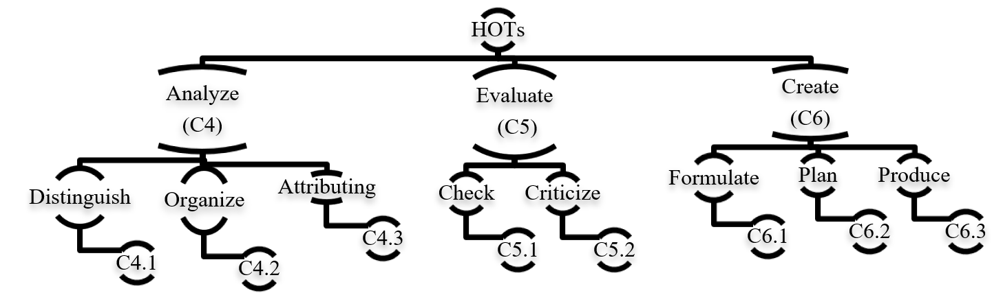

Figure 1. Cognitive process dimension

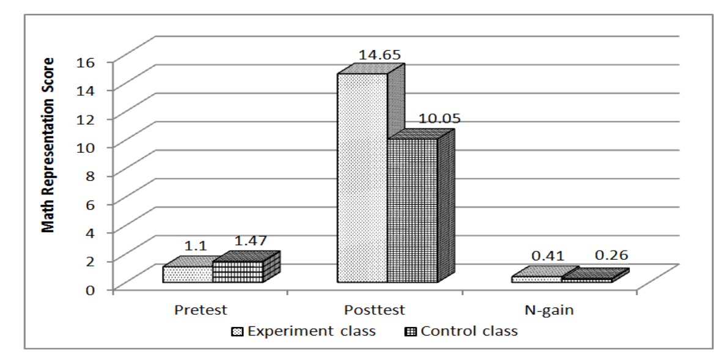 | 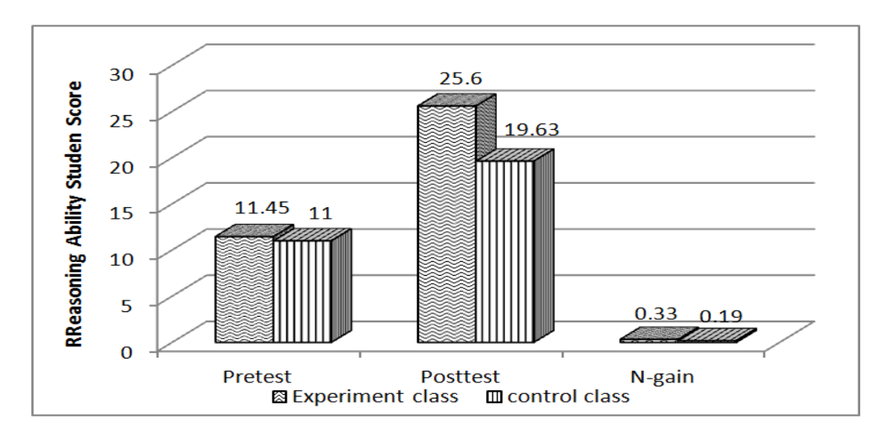
(a) | (b)
Figure 2. Pretest, posttest, and N-gain for (a) math representation ability students and (b) reasoning ability students
Table 1. Internal consistency reliability of biology test
SN | Indicator | Value
1 | Number of Item | 60
2 | Kuder Richardson (KR-20) | 0.620
3 | Cronbach's Alpha Based on Standardized Items | 0.617
4 | Mean Item Difficulty | 0.56
5 | Mean Item Difficulty | 0.4

- RESULTS AND DISCUSSION (10 PT)
In this section, it is explained the results of research and at the same time is given
the comprehensive discussion. Results can be presented in figures, graphs, tables and others that make
the reader understand easily [14], [15]. The discussion can be made in several sub-sections.

3.1. Sub section 1
Equations should be placed at the center of the line and provided consecutively with equation numbers in parentheses flushed to the right margin, as in (1). The use of Microsoft Equation Editor or MathType is preferred.

$E_{v}-E=\frac{h}{2.m} (k_{x}^{2}+k_{y}^{2}$) (1)

All symbols that have been used in the equations should be defined in the following text.

3.2. Sub section 2
Proper citation of other works should be made to avoid plagiarism. When referring to a reference item, please use the reference number as in [16] or [17] for multiple references. The use of ”Ref [18]...” should be employed for any reference citation at the beginning of sentence. For any reference with more than 3 or more authors, only the first author is to be written followed by et al. (e.g. in [19]). Examples of reference items of different categories shown in the References section. Each item in the references section should be typed using 8 pt font size [20]–[25].

3.2.1. Subsub section 1
yy
3.2.2. Subsub section 2
zz

- CONCLUSION (10 PT)
Provide a statement that what is expected, as stated in the "INTRODUCTION" section can ultimately result in "RESULTS AND DISCUSSION" section, so there is compatibility. Moreover, it can also be added the prospect of the development of research results and application prospects of further studies into the next (based on result and discussion).

ACKNOWLEDGEMENTS (10 PT)
Author thanks ... . In most cases, sponsor and financial support acknowledgments.

REFERENCES (10 PT)
The main references are international journals and proceedings. All references should be to the most pertinent, up-to-date sources and the minimum of references are 25 entries (for original research paper) and 50 entries (for review/survey paper). References are written in IEEE style. For more complete guide can be accessed at (http://ipmuonline.com/guide/refstyle.pdf). Use of a tool such as EndNote, Mendeley, or Zotero for reference management and formatting, and choose IEEE style. Please use a consistent format for references-see examples (8 pt):

- Journal/Periodicals
Basic Format:
J. K. Author, “Title of paper,” Abbrev. Title of Journal/Periodical, vol. x, no. x, pp. xxx-xxx, Abbrev. Month, year, doi: xxx.
Examples:
- M. M. Chiampi and L. L. Zilberti, “Induction of electric field in human bodies moving near MRI: An efficient BEM computational procedure,” IEEE Trans. Biomed. Eng., vol. 58, pp. 2787–2793, Oct. 2011, doi: 10.1109/TBME.2011.2158315.
- R. Fardel, M. Nagel, F. Nuesch, T. Lippert, and A. Wokaun, “Fabrication of organic light emitting diode pixels by laser-assisted forward transfer,” Appl. Phys. Lett., vol. 91, no. 6, Aug. 2007, Art. no. 061103, doi: 10.1063/1.2759475.

- Conference Proceedings
Basic Format:
J. K. Author, “Title of paper,” in Abbreviated Name of Conf., (location of conference is optional), year, pp. xxx–xxx, doi: xxx.
Examples:
- G. Veruggio, “The EURON roboethics roadmap,” in Proc. Humanoids ’06: 6th IEEE-RAS Int. Conf. Humanoid Robots, 2006, pp. 612–617, doi: 10.1109/ICHR.2006.321337.
- J. Zhao, G. Sun, G. H. Loh, and Y. Xie, “Energy-efficient GPU design with reconfigurable in-package graphics memory,” in Proc. ACM/IEEE Int. Symp. Low Power Electron. Design (ISLPED), Jul. 2012, pp. 403–408, doi: 10.1145/2333660.2333752.

- Book
Basic Format:
J. K. Author, “Title of chapter in the book,” in Title of His Published Book, X. Editor, Ed., xth ed. City of Publisher, State (only U.S.), Country: Abbrev. of Publisher, year, ch. x, sec. x, pp. xxx–xxx.
Examples:
- A. Taflove, Computational Electrodynamics: The Finite-Difference Time-Domain Method in Computational Electrodynamics II, vol. 3, 2nd ed. Norwood, MA, USA: Artech House, 1996.
- R. L. Myer, “Parametric oscillators and nonlinear materials,” in Nonlinear Optics, vol. 4, P. G. Harper and B. S. Wherret, Eds., San Francisco, CA, USA: Academic, 1977, pp. 47–160.

- M. Theses (B.S., M.S.) and Dissertations (Ph.D.)
Basic Format:
J. K. Author, “Title of thesis,” M.S. thesis, Abbrev. Dept., Abbrev. Univ., City of Univ., Abbrev. State, year.
J. K. Author, “Title of dissertation,” Ph.D. dissertation, Abbrev. Dept., Abbrev. Univ., City of Univ., Abbrev. State, year.
Examples:
- J. O. Williams, “Narrow-band analyzer,” Ph.D. dissertation, Dept. Elect. Eng., Harvard Univ., Cambridge, MA, USA, 1993.
- N. Kawasaki, “Parametric study of thermal and chemical nonequilibrium nozzle flow,” M.S. thesis, Dept. Electron. Eng., Osaka Univ., Osaka, Japan, 1993.

*In the reference list, however, list all the authors for up to six authors. Use et al. only if: 1) The names are not given and 2) List of authors more than 6. Example: J. D. Bellamy et al., Computer Telephony Integration, New York: Wiley, 2010.

See the examples:
REFERENCES
[1] P. Delgadoa, C. Vargasb, R. Ackermanc, and L. Salmerón, “Don’t throw away your printed books: A meta-analysis on the effects of reading media on reading comprehension,” Educ. Res. Rev., vol. 25, pp. 23–38, 2018, doi: 10.1016/j.edurev.2018.09.003.
[2] F. Reichert, D. Lange, and L. Chow, “Educational beliefs matter for classroom instruction: A comparative analysis of teachers’ beliefs about the aims of civic education,” Teach. Teach. Educ., vol. 98, pp. 1–13, 2020, doi: 10.1016/j.tate.2020.103248.
[3] J. Roick and T. Ringeisen, “Students’ math performance in higher education: examining the role of self-regulated learning and self-efficacy,” Learn. Individ. Differ., vol. 65, pp. 148–158, 2018.
[4] G. Ocak and A. Yamaç, “Examination of the relationships between fifth graders’ self-regulated learning strategies, motivational beliefs, attitudes, and achievement,” Educ. Sci. Theory Pract., vol. 13, no. 1, pp. 380–387, 2013.
[5] S. Li and J. Zheng, “The relationship between self-efficacy and self-regulated learning in one-to-one computing environment: The mediated role of task values,” Asia-Pacific Educ. Res., vol. 27, no. 6, pp. 455–463, 2018, doi: 10.1007/s40299-018-0405-2.
[6] B. J. Zimmerman and A. R. Moylan, “Self-regulation: where metacognition and motivation intersect,” in D. J. Hacker, J. Dunlosky, and A. C. Graesser, Eds., Handbook of Metacognition in Education, 2009, pp. 299–315.
[7] P. R. Pintrich, D. A. F. Smith, T. Duncan, and W. Mckeachie, A manual for the use of the motivated strategies for learning questionnaire (MSLQ). Ann Arbor, Michigan, 1991.
[8] M. Pressley and C. B. McCormick, Advanced educational psychology for educators, researchers, and policymakers. New York, USA: HarperCollins College Publishers, 1995.
[9] A. Bandura, Prentice-Hall series in social learning theory. Social foundations of thought and action: A social cognitive theory. Prentice-Hall, Inc., 1985.
[10] A. L. Dent and A. C. Koenka, “The relation between self-regulated learning and academic achievement across childhood and adolescence: a meta-analysis,” Educ. Psychol. Rev., vol. 28, no. 3, pp. 425–474, 2015, doi: 10.1007/s10648-015-9320-8.
[11] T. J. Cleary and A. Kitsantas, “Motivation and self-regulated learning influences on middle school mathematics achievement,” School Psych. Rev., vol. 46, no. 1, pp. 88–107, 2017.
[12] P. R. Pintrich, “Chapter 14 - The Role of Goal Orientation in Self-Regulated Learning,” in in M. Boekaerts, P. Pintrich, M. Zeidner, Eds., Handbook of Self-Regulation, San Diego, California: Academic Press, 2000, pp. 451–502.
[13] H. Vonkova and J. Hrabak, “The (in) comparability of ICT knowledge and skill self-assessments among upper secondary school students: The use of the anchoring vignette method,” Comput. Educ., vol. 85, pp. 191–202, 2015, doi: 10.1016/j.compedu.2015.03.003.
[14] F. Baier, A.-T. Decker, T. Voss, T. Kleickmann, U. Klusmann, and M. Kunter, “What makes a good teacher? The relative importance of mathematics teachers’ cognitive ability, personality, knowledge, beliefs, and motivation for instructional quality,” Br. J. Educ. Psychol., vol. 89, no. 4, pp. 767–786, 2019, doi: 10.1111/bjep.12256.
[15] A. M. Flanagan, D. C. Cormier, and O. Bulut, “Achievement may be rooted in teacher expectations: examining the differential influences of ethnicity, years of teaching, and classroom behaviour,” Soc. Psychol. Educ., vol. 23, pp. 1429–1448, 2020, doi: 10.1007/s11218-020-09590-y.
[16] F. M. van der Kleij, “Comparison of teacher and student perceptions of formative assessment feedback practices and association with individual student characteristics,” Teach. Teach. Educ., vol. 85, no. 1, pp. 175–189, 2019.
[17] R. G. Brockett and R. Hiemstra, Self-direction in adult learning: Perspectives on theory, research, and practice. London and New York: Routledge, 2020.
[18] R. Hiemstra and R. G. Brockett, “Reframing the Meaning of Self-Directed Learning: An Updated Modeltt,” in Adult Education Research Conference Proceedings, 2012, pp. 155–161.
[19] S. Geng, K. M. Y. Law, and B. Niu, “Investigating self-directed learning and technology readiness in blending learning environment,” Int. J. Educ. Technol. High. Educ., vol. 16, no. 17, pp. 1–22, 2019, doi: 10.1186/s41239-019-0147-0.
[20] J. R. Fraenkel, N. E. Wallen, and H. H. Hyun, How to design and evaluate research in education. New York, USA: McGraw-Hill, 2012.
[21] M. Honey and D. Marshall, “The impact of on-line muti-choice questions on undergraduate student nurses’ learning,” in Proceedings of the 20th Annual Conference of the Australasian Society for Computers in Learning in Tertiary Education (ASCILITE), 2003, pp. 236–243.
[22] R. A. Krueger and M. A. Casey, Focus groups: A practical guide for applied research. London: Sage Publications, Inc., 2015.
[23] J. W. Creswell and V. L. P. Clark, “Choosing a mixed methods design,” in Designing and Conducting Mixed Methods Research, California: Sage Publications, Inc., 2011, pp. 53–106.
[24] E. H. Mahvelati, “Learners’ perceptions and performance under peer versus teacher corrective feedback conditions,” Stud. Educ. Eval., vol. 70, 2021, doi: 10.1016/j.stueduc.2021.100995.
[25] K. Ismayilova and R. M.Klassen, “Research and teaching self-efficacy of university faculty: Relations with job satisfaction,” Int. J. Educ. Res., vol. 98, pp. 55–66, 2019, doi: 10.1016/j.ijer.2019.08.012.

BIOGRAPHIES OF AUTHORS (10 PT)
The recommended number of authors is at least 2. One of them as a corresponding author.
Please attach clear photo (3x4 cm) and vita. Example of biographies of authors:

 | Masitah Shahrill is a Senior Assistant Professor and Teacher Educator at the Sultan Hassanal Bolkiah Institute of Education (SHBIE), Universiti Brunei Darussalam (UBD). She was appointed lecturer in the university in 2001 and went on to pursue her graduate studies in mathematics education at the University of Melbourne, Australia. She was appointed as Senior Lecturer in 2013 and as Senior Assistant Professor in 2017. She is passionate about raising the quality of teaching and learning of students and their development in the schools and in the higher education settings. Dr Masitah’s research interests lie in the teacher and teacher education, mathematics education, higher education, 21st Century teaching and learning, school-based assessment, classroom research, and youth practices and their education. She can be contacted at email: masitah.shahrill@ubd.edu.bn.
 | Hanif Cahyo Adi Kistoro is a Ph.D. Candidate, Department of Educational Research and Evaluation, Graduate School, Universitas Negeri Yogyakarta, Colombo Street No.1 Yogyakarta, Yogyakarta 55281, Indonesia & Lecturer, Department of Islamic Education, Universitas Ahmad Dahlan, Indonesia. His research focuses on physics education, Scaffolding in education, Scientific literacy, project-based learning, Supersymmetry in Quantum, STEM education and literacy. He can be contacted at email: hanifcahyo.2018@student.uny.ac.id; hanif.kistoro@pai.uad.ac.id.
 | Azlina Mohd Kosnin received the Ph.D. degree in education from the University of Newcastle, U.K. She has over 20 years of experience as an Academician with the Universiti Teknologi Malaysia (UTM), where she is currently an Associate Professor and the Chair of the School of Education, Faculty of Social Sciences and Humanities. Her current research interest includes students’ learning and development at various levels and areas of education. Her publication topics imcluding ecology, educational courses, educational institutions, engineering education, natural resources, recycling, sustainable development. She can be contacted at email: p-azlina@utm.my.

